**Name: AKSHAY SING JJ**

**Ex. No: 4 Roll no:231901005**

**SQL INJECTION LAB**

**Aim:**

To do perform SQL Injection Lab in TryHackMe platform to exploit various

vulnerabilities.

**Algorithm:**

1. Access the SQL Injection Lab in TryHackMe platform using the link- https://tryhackme.com/r/room/sqlilab
2. Click Start Attack Box to run the instance of Kali Linux distribution.
3. Perform SQL injection attacks on the following-
4. Input Box Non-String
5. Input Box String
6. URL Injection
7. POST Injection
8. UPDATE Statement
9. Perform broken authentication of login forms with blind SQL injection to extract admin password
10. Perform UNION-based SQL injection and exploit the vulnerable book search function to retrieve the flag

**Output:**

**SQL INJECTION LAB**

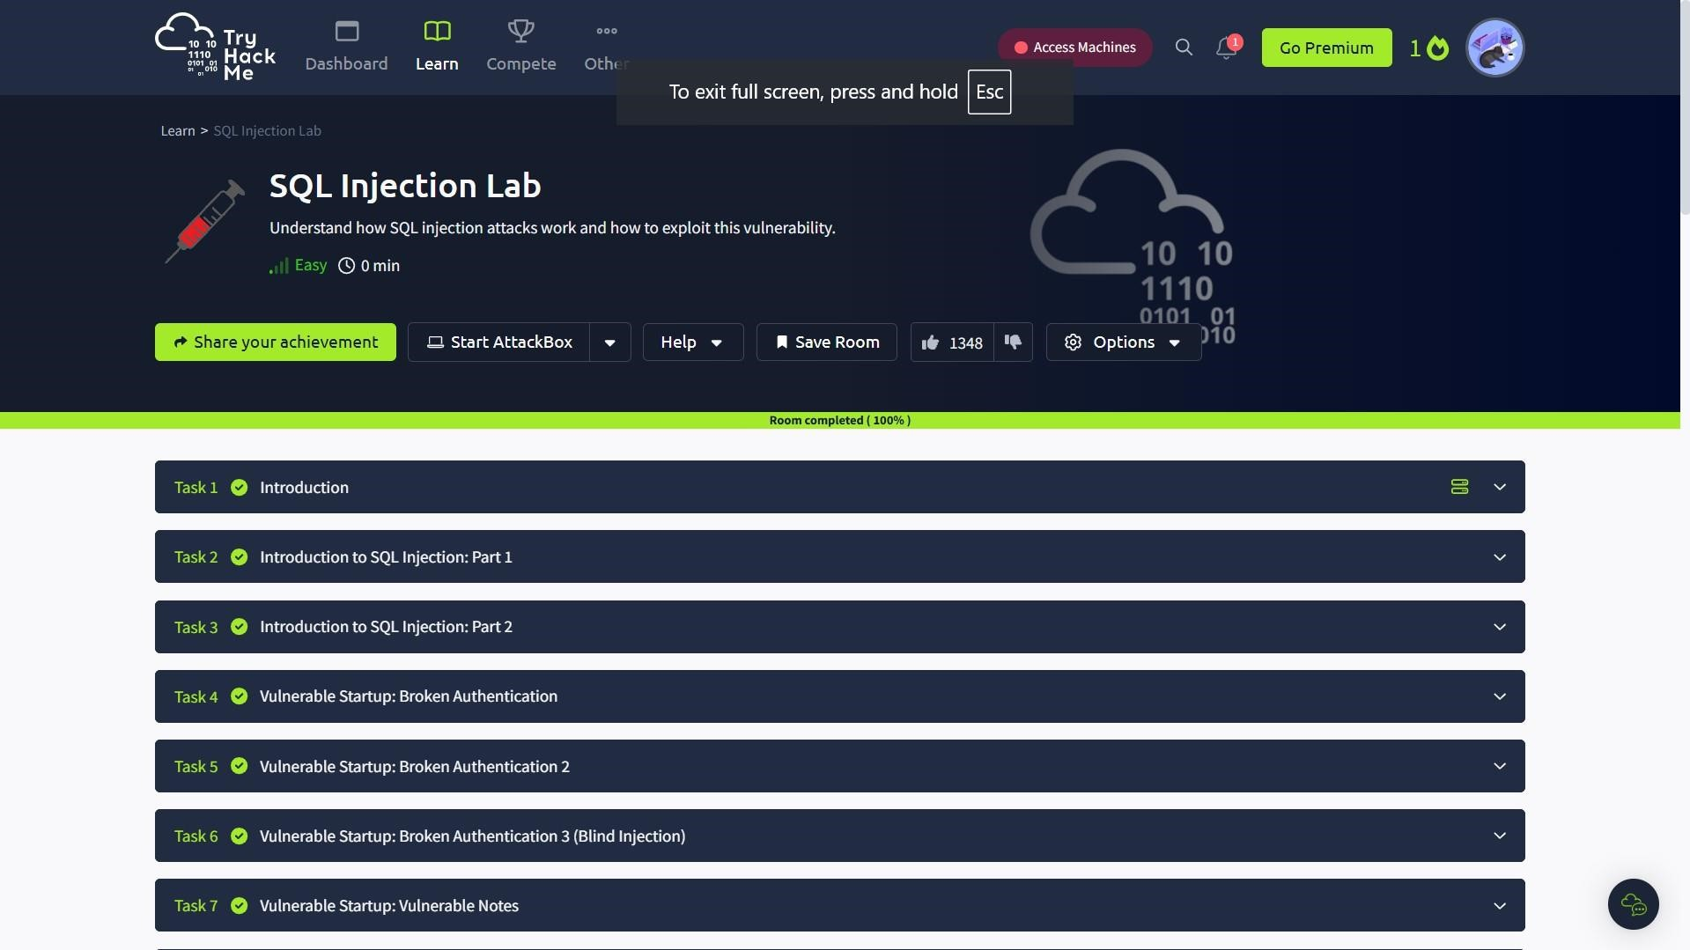

**Result:**

Thus, the various exploits were performed using SQL Injection Attack in TryHackMe platform.